**October 2022**

**Healthy Celebrations**

Parties can be a fun way to celebrate special occasions and holidays! They usually involve decorations, games, and music! They also commonly include cake, ice cream, cookies, and candy. While traditional party foods are okay to serve occasionally, they do not have to be the focus. Birthdays, holidays, and other special events are great chances to promote healthy eating and active play.

Involve children, families, and staff in planning and preparing for celebrations. The following ideas will help you include healthy options for special events!

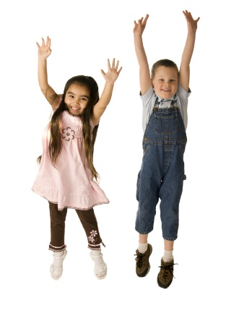

**Healthy Foods for Celebrations**

Serve healthy foods in a fun way. Get children involved in making these fun and good-for-you treats. As always, be mindful of choking hazards and food allergies for children.

* **Fruit kabobs:** Supply blunt-ended skewers and fresh fruit like cut-up grapes, strawberries, kiwi slices, and apple wedges for the children to make their fruit kabobs. For younger children, skip the skewers and provide a rainbow of colorful fruits they can enjoy.
* **Fruit pizza:** A whole grain crust such as a pita or tortilla, yogurt spread, and fresh fruit make this a tasty treat! Check out this [Fun Fruit Breakfast Pizza](https://theicn.org/cnrb/recipes-for-centers-breakfast/fun-fruit-breakfast-pizza-usda-recipe-for-cacfp/) recipe.
* **Fruit salad:** Mix a rainbow of fruit pieces in a bowl with a small amount of yogurt.
* **Popcorn party:** Popcorn is a whole grain and fun snack. Skip the butter and salt and add other homemade seasonings to keep it a healthy treat. Check out these easy and healthy popcorn flavor [recipes](https://www.liveeatlearn.com/easy-homemade-popcorn-seasoning/).
* **Yogurt parfait:** Let the children layer yogurt, granola or crunchy cereal, and fruit such as blueberries and raspberries in clear plastic cups so they can see their colorful creations.
* **Trail mix:** Children can assemble their mix from the following: whole grain cereals (try different shapes like squares, O’s, and puff-type cereals), dried fruit, pretzels, nuts, etc.
* **Freezer pops:** Freeze 100% fruit juice and enjoy on a warm day.

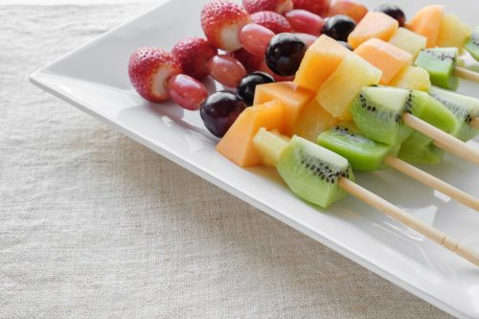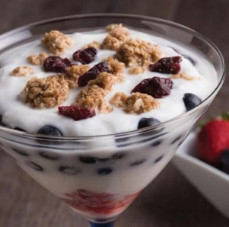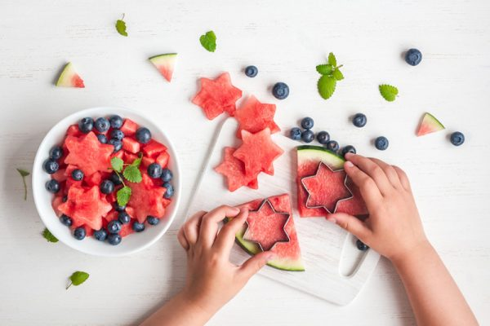

**Festive Foods**

Make healthy foods fun and festive with these ideas.

* **Holiday fun:** Turn oranges into pumpkins or string cheese packages into ghosts by drawing faces on them.
* **Fun shapes:** Use cookie cutters to cut fruits, cheese, sandwiches, or bread into shapes that fit the theme (such as hearts, flowers, leaves, stars, or pumpkins).
* **Get colorful:**
  + Choose foods that fit the festivities, such as red fruits like strawberries for Valentine’s Day; or red, white, and blue fruits (ex., watermelon, bananas, and blueberries) for Independence Day.
  + Scatter colorful or holiday-themed sprinkles onto oatmeal or yogurt.
  + Serve food on colorful plates and drinks in festive cups.

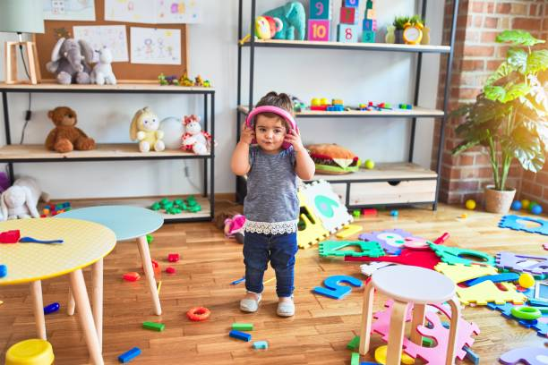

**Creative Activities**

Celebrate holidays and special events with fun and engaging activities.

* **Dance party:** Host a dance party and let children be the DJs.
* **Group activities:** Have a mini talent show, scavenger hunt, or show-and-tell.
* **Decorate together:** Create centerpieces, banners, placemats, signs, cards, bracelets, or headbands.
* **Game time:**Plan activities like soccer, obstacle courses, tag, ball tosses, or jump rope.
* **Healthy Halloween:** Instead of candy, children can dress up and trick-or-treat for trinkets, toys, and other fun non-food items.

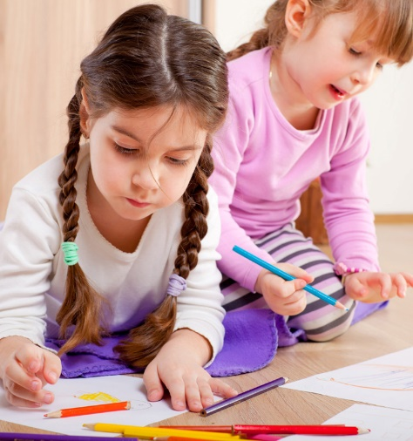



**Birthday Celebrations**

Celebrate children on their birthdays with fun activities instead of with food.

* **Special treatment:** The birthday child gets privileges for the day, like being the teacher’s helper, sitting next to the teacher during meals or circle time, wearing a birthday crown or badge, or choosing a game or activity for the class to play.
* **Sharing time:** Allow the child to bring in a special book, a favorite toy, or an item to share with their friends.
* **Group celebration:** Plan one party each month to celebrate all the birthdays in that month instead of hosting a separate celebration for each child. Check out the Creative Activities section above for ideas.

**Get Family Support**

Include food celebration policies in family orientation materials. Request that families bring in healthy snacks or non-food items when they want to provide a special treat. Provide a list of healthy food and non-food options. If you ask families to contribute a food item for a special event, create a sign-up that includes only healthy options.

[Healthy Bites](https://dpi.wi.gov/sites/default/files/imce/community-nutrition/pdf/HealthyBites.pdf) provides sample letters and forms to send to families about how to keep celebrations healthy. “Appendix H” provides a list of healthy foods, non-food activity ideas, and a sample Birthday Request Form. “Appendix I” provides a sample letter to families with healthy celebration suggestions.

**Items Brought From Home**

Keep children with food allergies safe and request that food brought from home be store-bought only. Foods should have a label containing ingredients to identify allergens.

**More Information**

For more ideas on how to celebrate specific holidays in a healthy way, check out USDA’s Team Nutrition [Classroom Celebrations](https://www.fns.usda.gov/sites/default/files/tn/dmp_tgcelebrations.pdf).

**Mealtime Discussion Prompts**

During mealtime, spark positive conversations with children about healthy celebrations using the questions below.

* What are some family events or celebrations you enjoy at home?
* How do you celebrate birthdays or holidays?
* What foods do you eat at these special events?
* Do you help decorate or make food for the celebrations?
* What is your favorite holiday and why?

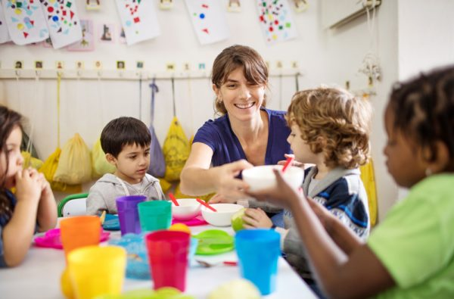

**Menu Ideas**

The following menu ideas provide a variety of foods, colors, and textures, along with ideas for connections to certain holidays. Some recipes contain multiple food components listed in parentheses after the recipe.

**Breakfast**

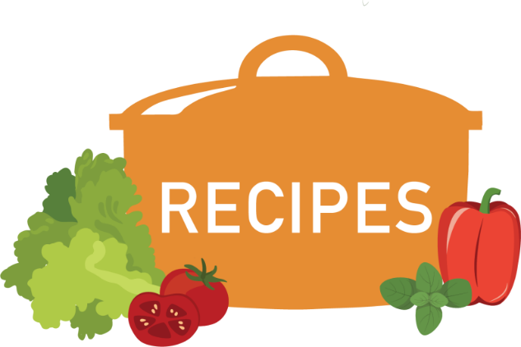

You can find the featured recipes from the Menu Ideas section in the resources below:

* The [Child Nutrition Recipe Box](https://theicn.org/cnrb/?utm_source=website&utm_medium=menue&utm_campaign=cnrb_icn) has USDA standardized recipes for child care centers and family child care homes.
* The [Child Nutrition Recipe Box: New CACFP Lunch/Supper Recipes](https://theicn.org/cnrb/2022-cacfp-recipes/) has standardized recipes per age group (3–5 and 6–18 year-olds) and for servings of 6, 25, and 50.

**References**

Bond, S. (2020, March 16). *Easy homemade popcorn seasoning*. Live Eat Learn. <https://www.liveeatlearn.com/easy-homemade-popcorn-seasoning/>

Institute of Child Nutrition. (n.d.). *Breakfast burrito with salsa – USDA recipe for child care centers*. Child Nutrition Recipe Box.<https://theicn.org/cnrb/recipes-for-centers-breakfast/breakfast-burrito-with-salsa-usda-recipe-for-cacfp/>

Institute of Child Nutrition. (n.d.). *Breakfast pizza with hashbrown crust – USDA recipe for child care centers*. Child Nutrition Recipe Box. <https://theicn.org/cnrb/recipes-for-centers-breakfast/breakfast-pizza-with-hashbrown-crust-usda-recipe-for-cacfp/>

Institute of Child Nutrition. (n.d.). *Chicken stir-fry – USDA recipe for child care centers*. Child Nutrition Recipe Box. <https://theicn.org/cnrb/recipes-for-centers-main-dishes/chicken-stir-fry-usda-recipe-for-cacfp/>

Institute of Child Nutrition. (n.d.). *Child nutrition recipe box*.<https://theicn.org/cnrb/>

Institute of Child Nutrition. (n.d.). *Cran-orange relish – USDA recipe for child care centers*. Child Nutrition Recipe Box. <https://theicn.org/cnrb/recipes-for-centers-accompaniments/cran-orange-relish-usda-recipe-for-cacfp/>

Institute of Child Nutrition. (n.d.). *Fun fruit breakfast pizza – USDA recipe for child care centers*. Child Nutrition Recipe Box. <https://theicn.org/cnrb/recipes-for-centers-breakfast/fun-fruit-breakfast-pizza-usda-recipe-for-cacfp/>

Institute of Child Nutrition. (n.d.). *New CACFP lunch/supper recipes*. Child Nutrition Recipe Box. <https://theicn.org/cnrb/2022-cacfp-recipes/>

Oregon State University. (2020, March 3). *Healthy and fun celebrations at home, school or anywhere*. Food Hero. <https://foodhero.org/magazines/healthy-and-fun-celebrations>

U.S. Department of Agriculture, Food and Nutrition Service. (2014, April 10). *Discover MyPlate teacher’s guide classroom celebrations*. <https://www.fns.usda.gov/sites/default/files/tn/dmp_tgcelebrations.pdf>

U.S. Department of Agriculture, Food and Nutrition Service. (2018, September 13). *Nibbles for health: Healthy celebrations, lasting memories*. <https://www.fns.usda.gov/sites/default/files/resource-files/NibblesHealthyCelebrations_Eng.pdf>

Wisconsin Department of Public Instruction. (2019, May). *Healthy bites: A Wisconsin guide for improving childhood nutrition*. 2nd ed. <https://dpi.wi.gov/sites/default/files/imce/community-nutrition/pdf/HealthyBites.pdf>